|  |  |  |
| --- | --- | --- |
|  |  |  |
| **PROJECT TITLE** | **:** | **Personal Finance Tracker and Finance Advisor** |
|  |  |  |
| **DATE OF SUBMISSION** | **:** | **6th June, 2023** |
|  |  |  |
| **SUBMITTED TO** | **:** | Mr. Kashif Mehmood |
| **NAME:** |  | Muhammad Zain Paracha |
|  |  |  |

Table of Contents

Problem Definition 2

Scope of Project 4

Objectives 6

Introduction 6

Feasibility 7

Output 7

Tools 7

Technical Skills learnt 7

Addressing Knowledge 8

**Problem Definition**

The problem is to create a Personal Finance Tracker app using Kotlin and Firebase that allows users to manage their transactions, view transaction details, generate reports and tell investment plans in crypt by finance advisor. The app should provide a user-friendly interface and ensure secure authentication using Firebase.

**Scope of Project**

* The scope of the project includes the following features:
* User authentication using Firebase Authentication.
* Inserting and managing transactions.
* Viewing transaction details.
* Providing visibility options for transactions.
* Generating transaction reports.
* Ensuring data security and integrity using Firebase Realtime Database.
* Designing a user-friendly and intuitive interface.
* Ensuring proper error handling and validation of user input.

**Objectives**

* Create a secure and reliable user authentication system using Firebase Authentication.
* Implement CRUD (Create, Read, Update, Delete) operations for transactions using Firebase Realtime Database.
* Design and develop an intuitive user interface for seamless user experience.
* Provide transaction visibility options, such as public, private, or shared with specific users.
* Generate transaction reports based on selected filters and display them to the user.
* Ensure proper error handling and validation of user input to enhance the app's robustness.
* Learn and apply Kotlin programming language concepts to build an Android application.
* Gain hands-on experience with Firebase integration and database management.
* Learn about data security and privacy considerations when handling sensitive user information.

**Introduction**

The Expense Tracker app aims to provide users with a convenient way to manage their financial transactions. By securely authenticating users through Firebase Authentication, the app ensures the privacy and security of user data. Users can add, edit, and delete transactions, view transaction details, generate reports. The app's user-friendly interface and seamless integration with Firebase make it a powerful tool for tracking and analyzing personal expenses.

**Feasibility**

The project is feasible as it leverages the capabilities of Kotlin programming language and Firebase services. Kotlin offers a robust and expressive syntax for Android app development, while Firebase provides a reliable backend infrastructure for user authentication and data storage. Both technologies have extensive documentation and community support, making it feasible to build the app with adequate resources and technical knowledge.

**Output**

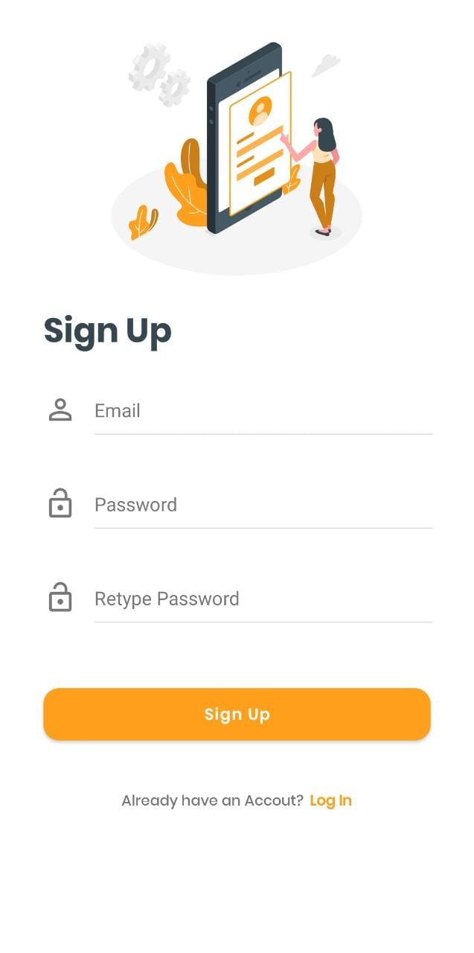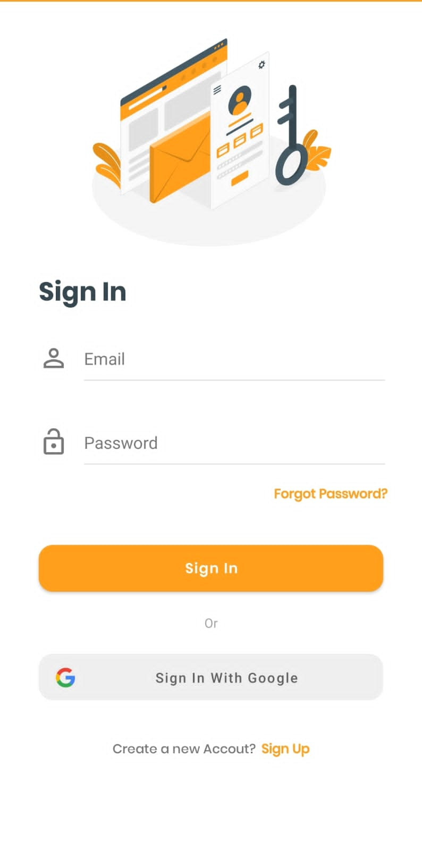

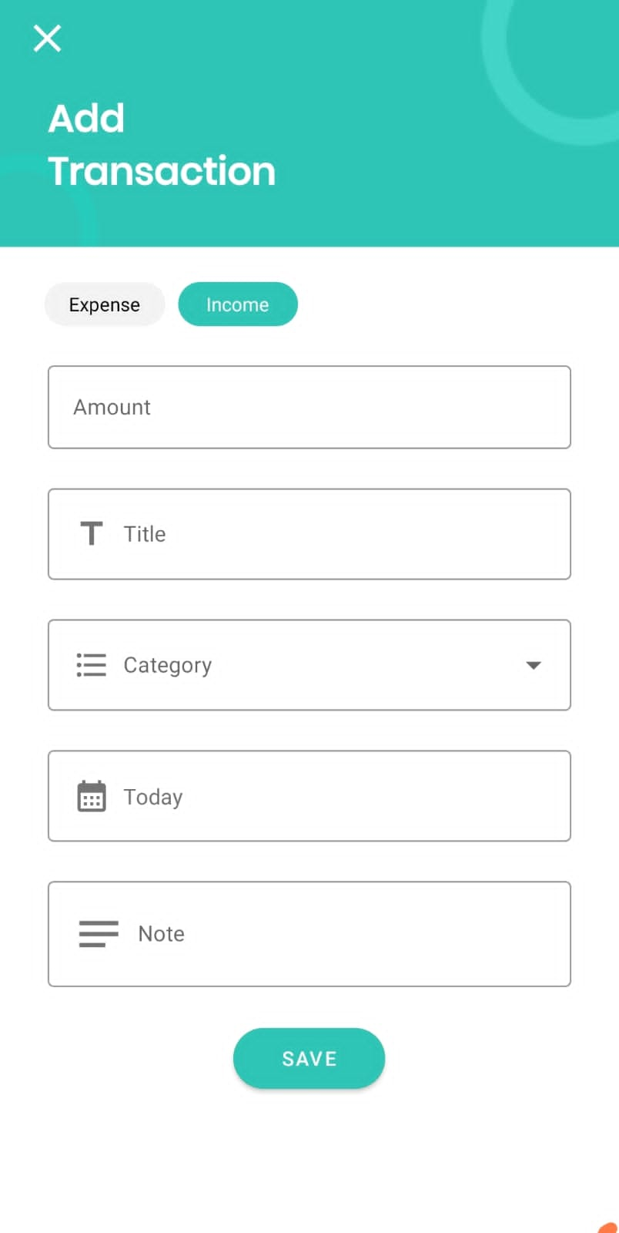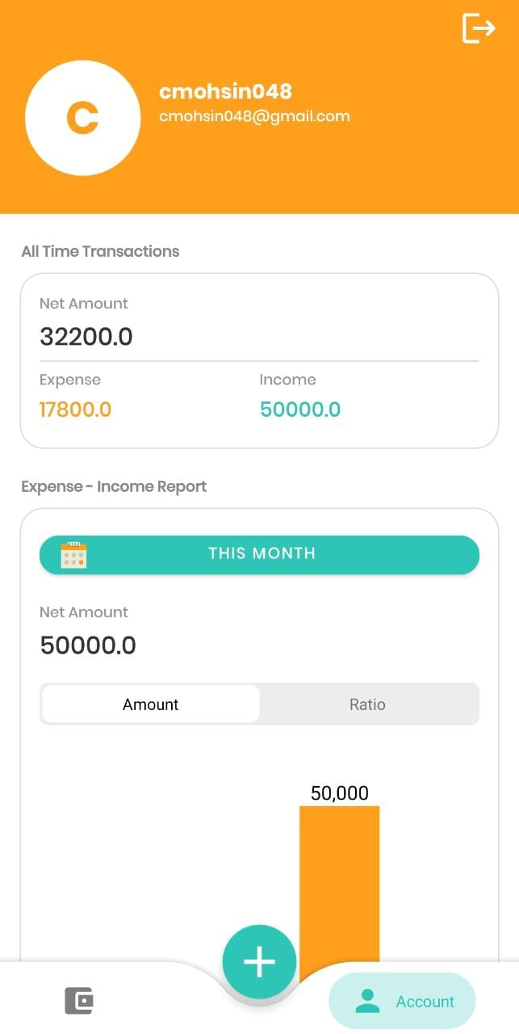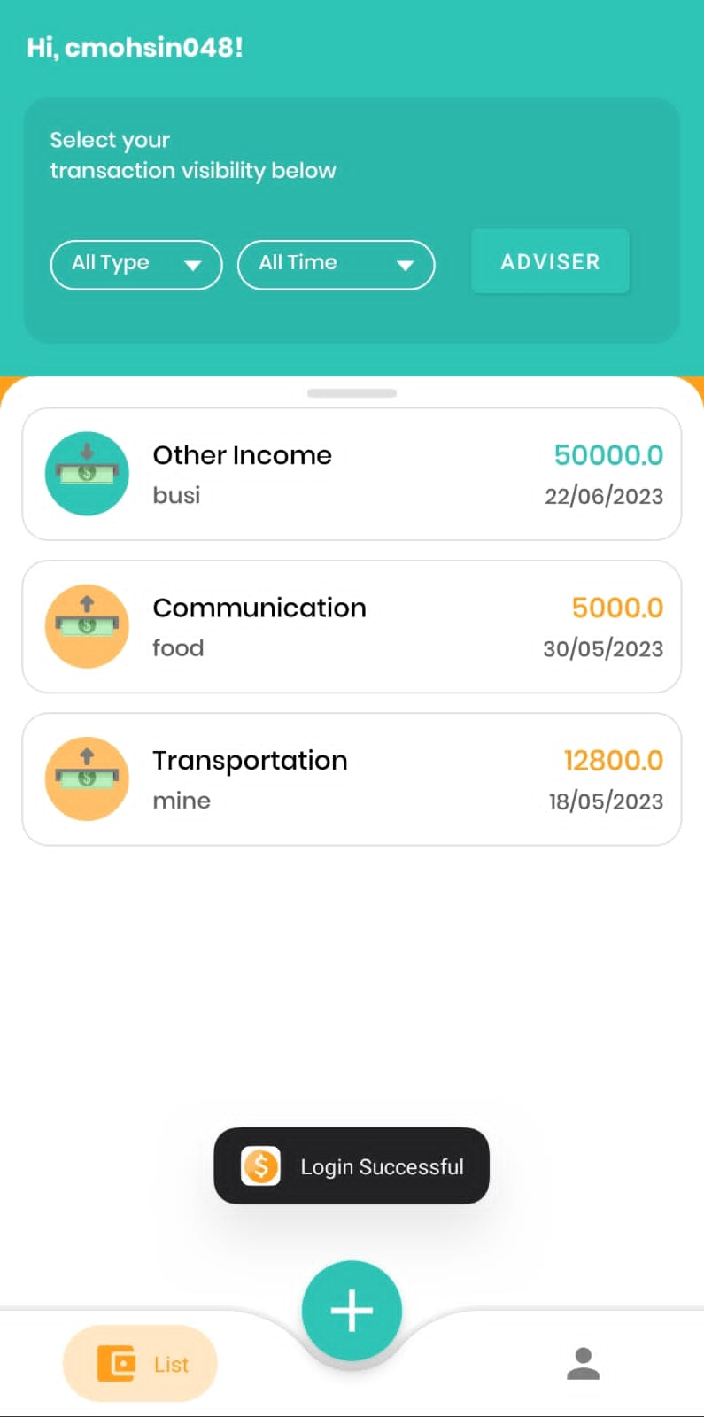

The expected output of this project is an Android Expense Tracker app built with Kotlin and integrated with Firebase services. The app will allow users to authenticate securely, manage their transactions, view transaction details, generate reports and also added a finance advisor which tells investments in crypto. The app's user interface will be intuitive and user-friendly, providing a seamless experience for tracking and analyzing personal expenses.

**Tools**

* Android Studio: Integrated Development Environment (IDE) for Android app development.
* Kotlin: Programming language for Android app development.
* Firebase: Backend infrastructure for user authentication and data storage.
* Firebase Authentication: For secure user authentication.
* Firebase Realtime Database: For storing and managing transaction data.

**Technical Skills learnt**

* Kotlin programming language for Android app development.
* Firebase integration for user authentication and data storage.
* CRUD operations (Create, Read, Update, Delete) using Firebase Realtime Database.
* User interface design and development.
* Error handling and input validation.
* Main part is we done is to add finance advisor and give simple user interface and done this work for all hostel students which can use this for their expenses savings.

**Addressing Knowledge**

Through this project, we will gain knowledge and hands-on experience in the following areas:

* Android app development using Kotlin.
* User authentication using Firebase Authentication.
* Firebase Realtime Database for data storage and retrieval.
* Designing user-friendly interfaces for mobile applications.
* Error handling and input validation in Android apps.

**References:**

* From there we have used authentication part of login <https://github.com/firebase/quickstart-android>
* Idea to make app for users: https://androidexample365.com/an-amazing-expense-tracker-app-with-great-features-and-beautiful-ui/